Lab: Lab 3 — ALU Circuit Design and Simulation with Logisim
Name: Solomon Ewusi | Student ID: N01659373
Date: October 3, 2026

Please refer to the lab manual posted on the blackboard and fill in the blanks in the following table as your lab report.

Notice: All labs are individual work and submission. All academic misconduct behaviors will be penalized to the maximum extent possible according to college policy. Thanks for your attention. (Reference Link: About Academic Misconduct)

Fill in all the lab report submission requirements in the following table. Please add more rows if necessary.

Requirements | Your submissions (Answers/Source Code/Screenshots/File Submissions, etc.)  Please notice: If it is required to submit a separate file, please attach it separately on the blackboard.
Your design file (.circ file) | Please submit the design as a separate file.  ALU2.circ (Logisim-evolution v5.0.0) is attached separately on Blackboard
Screenshots of the simulation results (For each of the 8 ALU functions, the report must show at least one screenshot of the simulation results and write the explanation of what are the simulation inputs and outputs.) | PART A: FULL ALU (MAIN CIRCUIT), ONE SCREENSHOT PER FUNCTION  All eight tests in main use the same inputs: A = 0000000011110101 (00F5) and B = 0000000000000011 (0003). Only the 3-bit Control_Input (S2 S1 S0) changes between screenshots.  Function 1: Addition (S2 S1 S0 = 000)  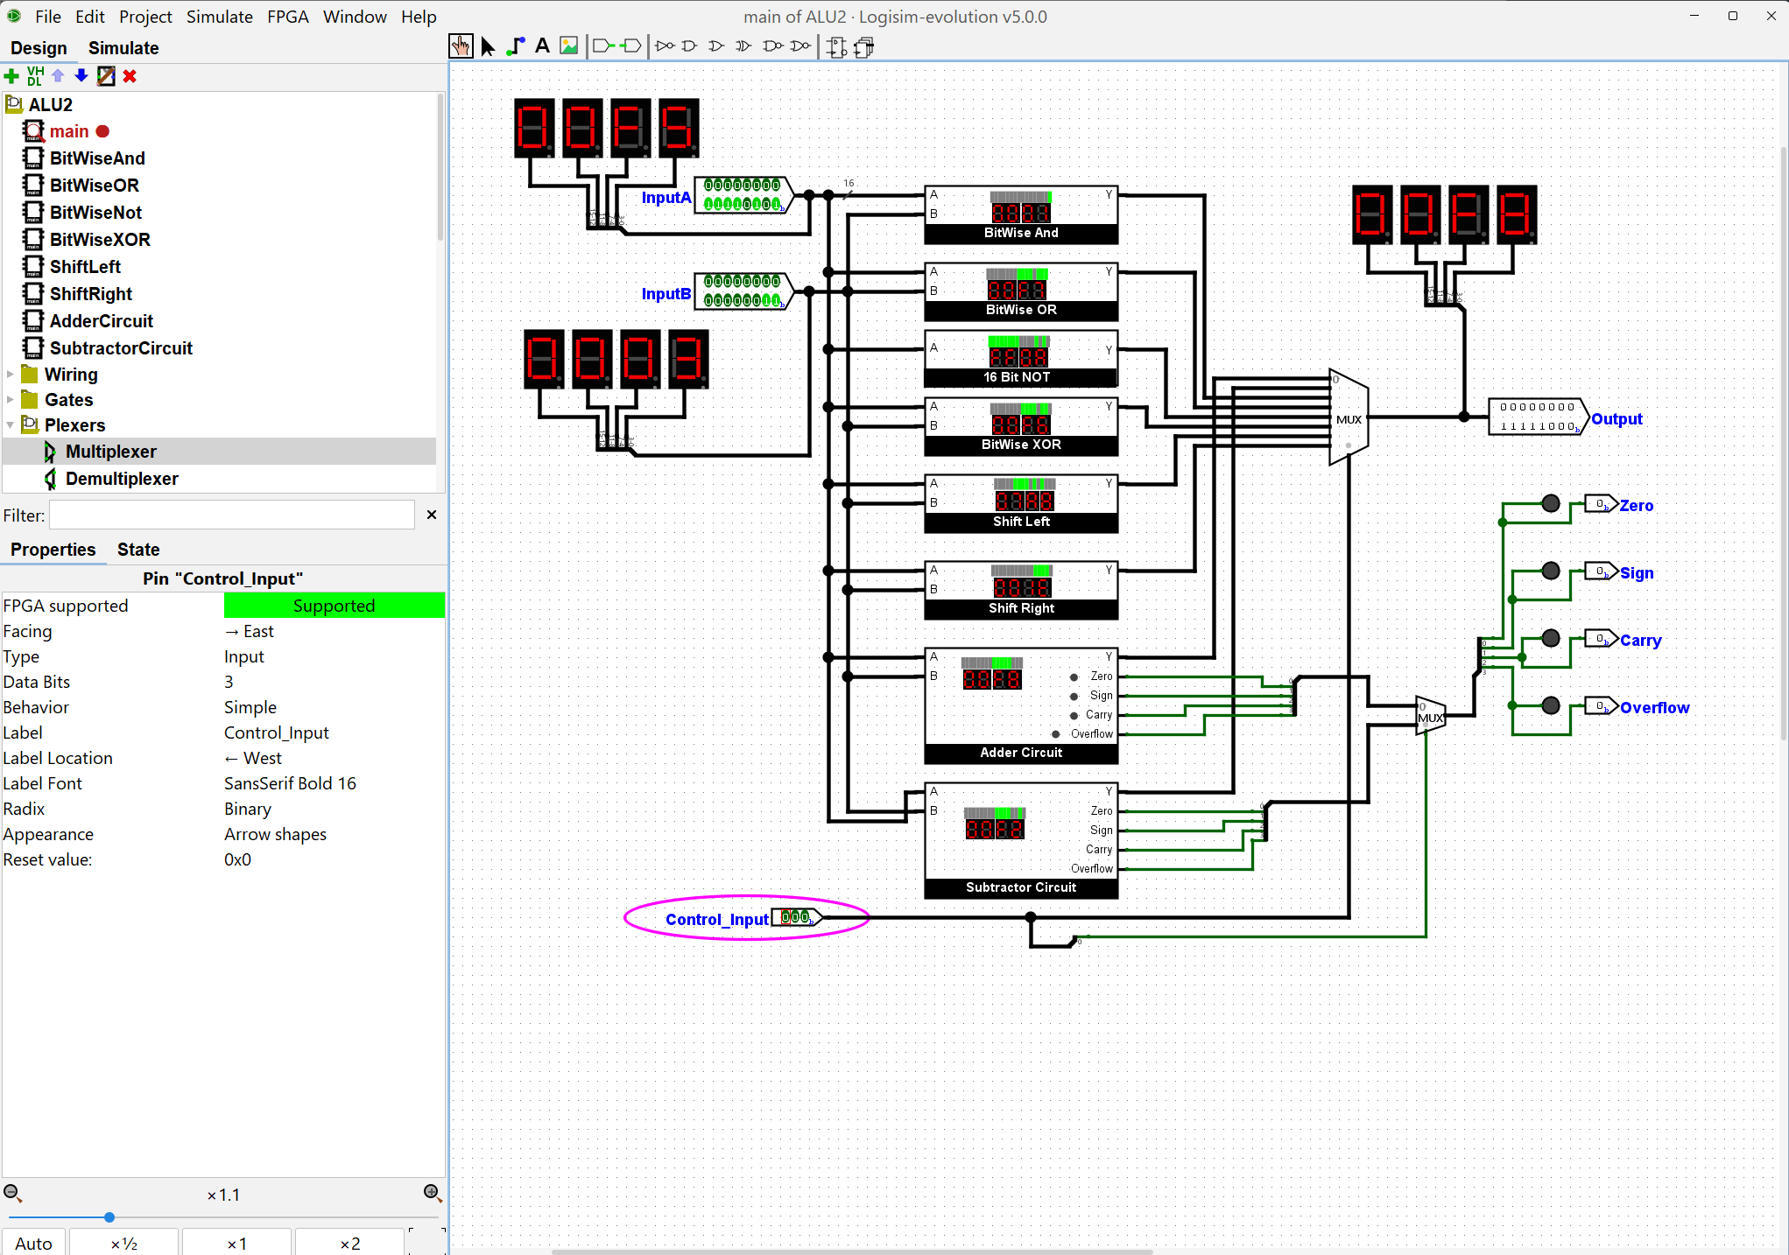  Inputs: A = 0000000011110101 (hex 00F5, decimal 245), B = 0000000000000011 (hex 0003, decimal 3), Control_Input = 000. Output: 0000000011111000 (hex 00F8, decimal 248), so A + B = 245 + 3 = 248. Zero, Sign, Carry and Overflow are all 0. Because S0 = 0, the flag multiplexer passes the Adder's flags to the flag outputs.  Function 2: Subtraction (S2 S1 S0 = 001)  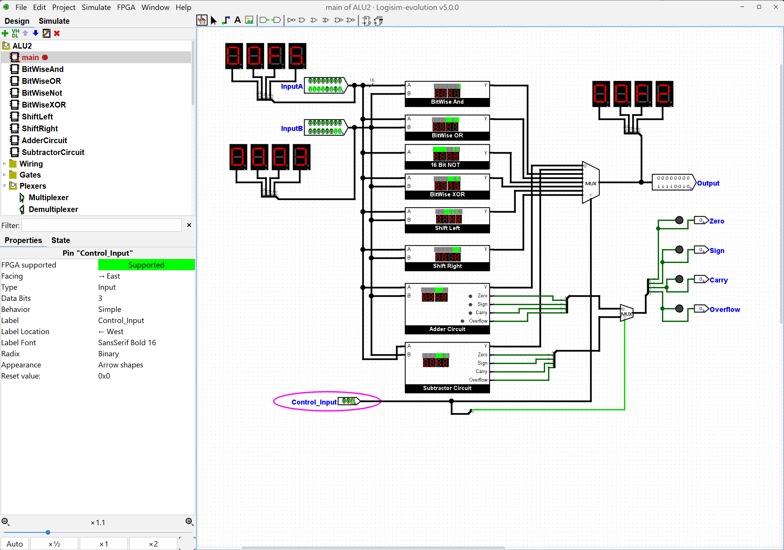  Inputs: A = 0000000011110101 (hex 00F5, decimal 245), B = 0000000000000011 (hex 0003, decimal 3), Control_Input = 001. Output: 0000000011110010 (hex 00F2, decimal 242), so A - B = 245 - 3 = 242. All four flags are 0. Because S0 = 1, the flag multiplexer now passes the Subtractor's flags instead of the Adder's.  Function 3: Logic AND (S2 S1 S0 = 010)  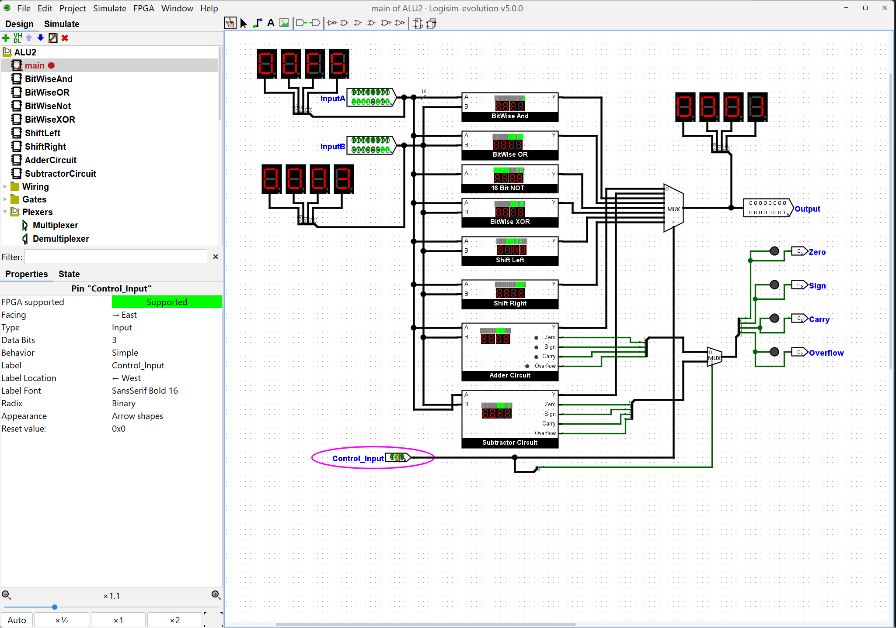  Inputs: A = 0000000011110101 (hex 00F5, decimal 245), B = 0000000000000011 (hex 0003, decimal 3), Control_Input = 010. Output: 0000000000000001 (hex 0001). Each output bit is 1 only where both A and B have a 1. The only such position is bit 0.  Function 4: Logic OR (S2 S1 S0 = 011)  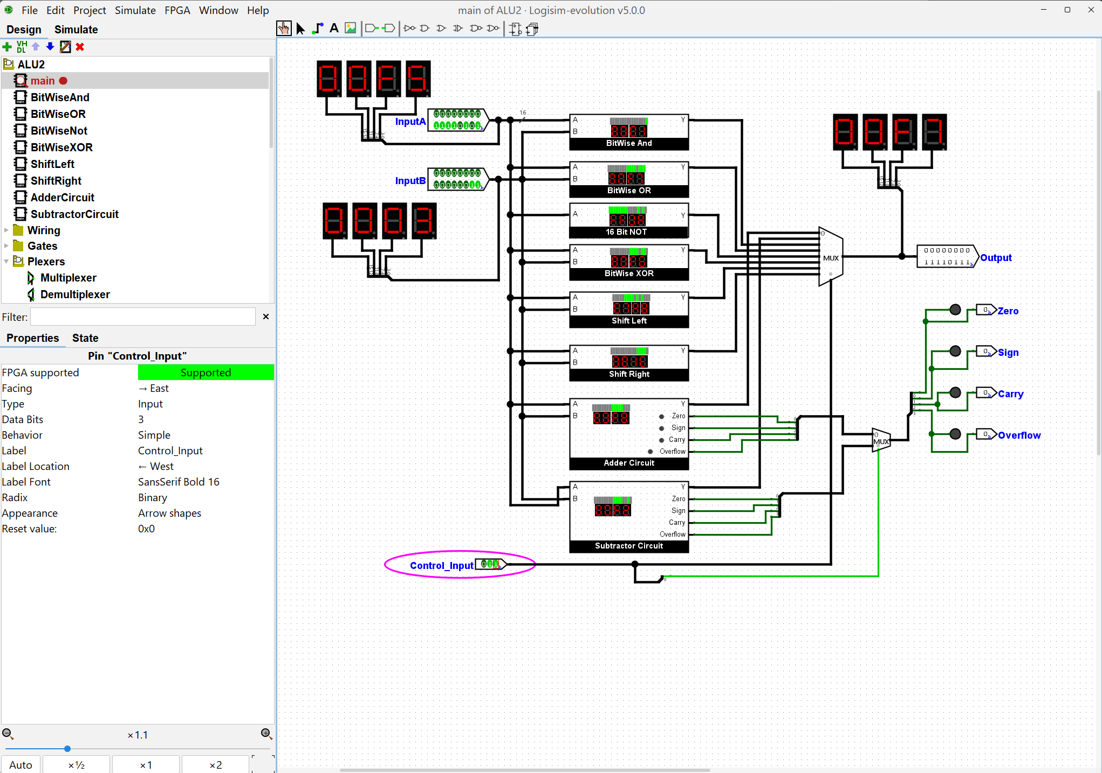  Inputs: A = 0000000011110101 (hex 00F5, decimal 245), B = 0000000000000011 (hex 0003, decimal 3), Control_Input = 011. Output: 0000000011110111 (hex 00F7). Each output bit is 1 where A or B (or both) has a 1, so B's bit 1 is added to A's pattern.  Function 5: NOT A (S2 S1 S0 = 100)  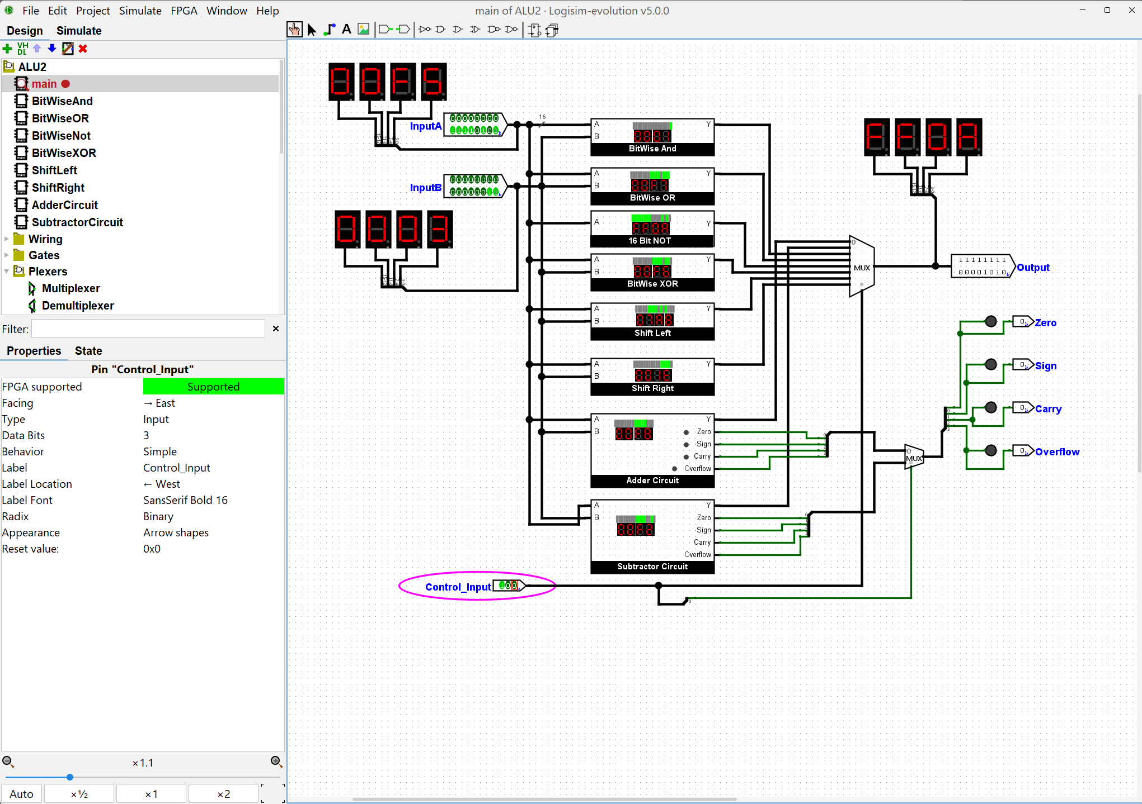  Inputs: A = 0000000011110101 (hex 00F5, decimal 245); B is not used. Control_Input = 100. Output: 1111111100001010 (hex FF0A). Every bit of A is inverted: each 0 becomes 1 and each 1 becomes 0.  Function 6: Logic XOR (S2 S1 S0 = 101)  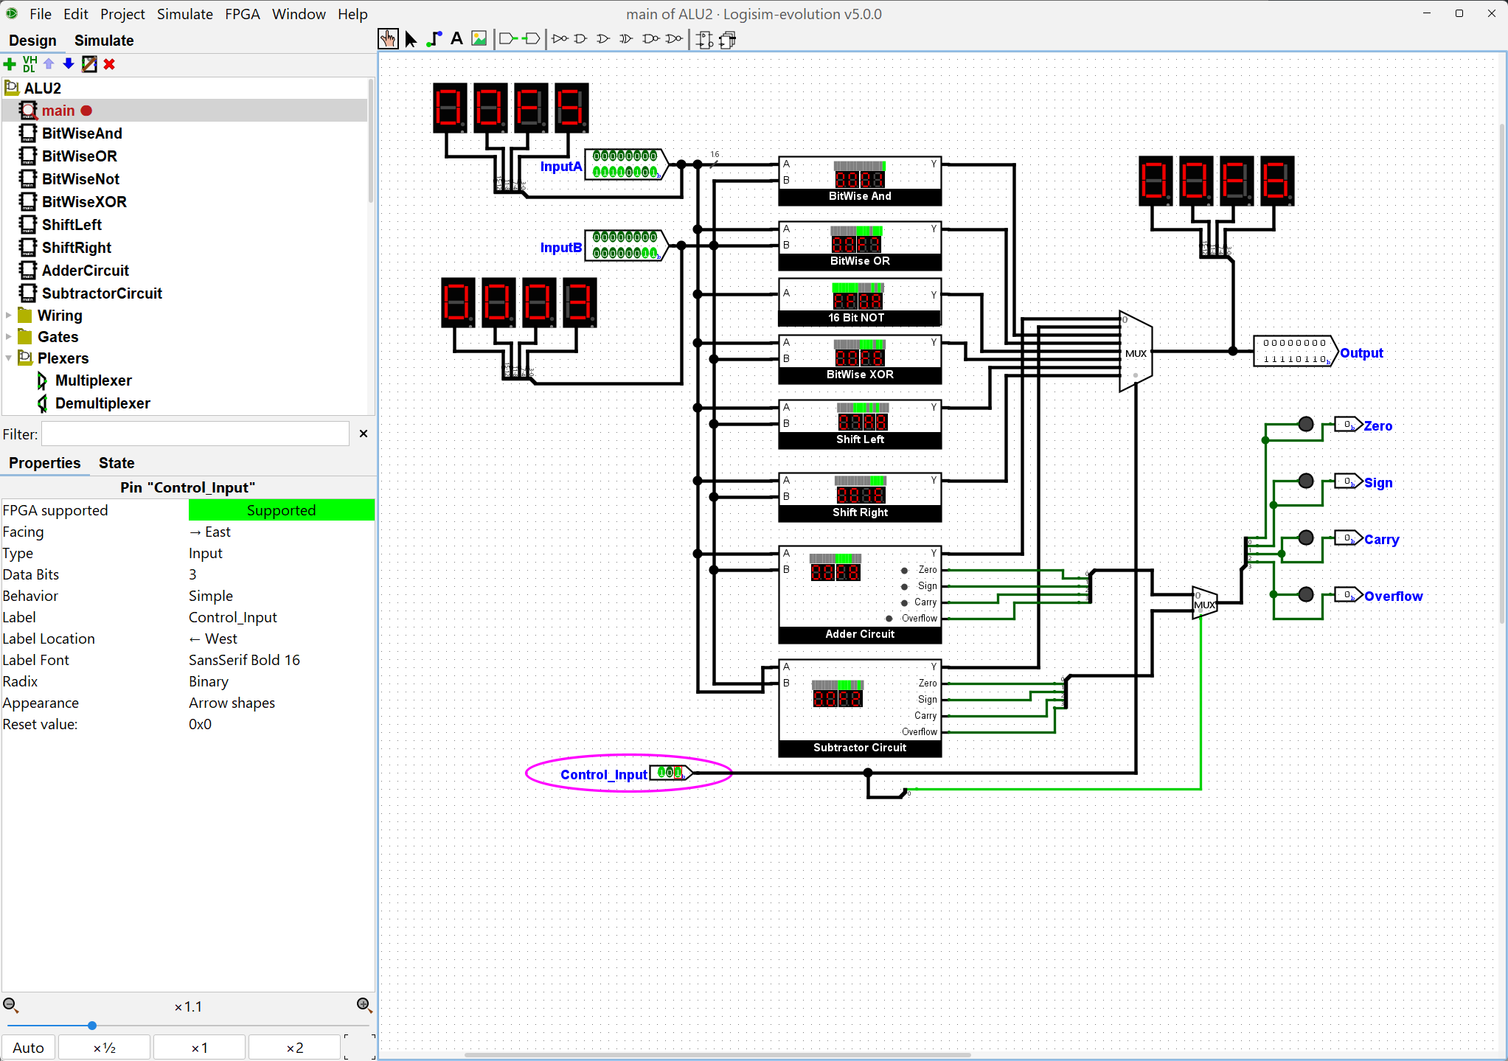  Inputs: A = 0000000011110101 (hex 00F5, decimal 245), B = 0000000000000011 (hex 0003, decimal 3), Control_Input = 101. Output: 0000000011110110 (hex 00F6). Each output bit is 1 only where A and B differ. Bits 0 and 1 are where B has a 1, so they are flipped relative to A.  Function 7: Shift A Left by B Bits (S2 S1 S0 = 110)  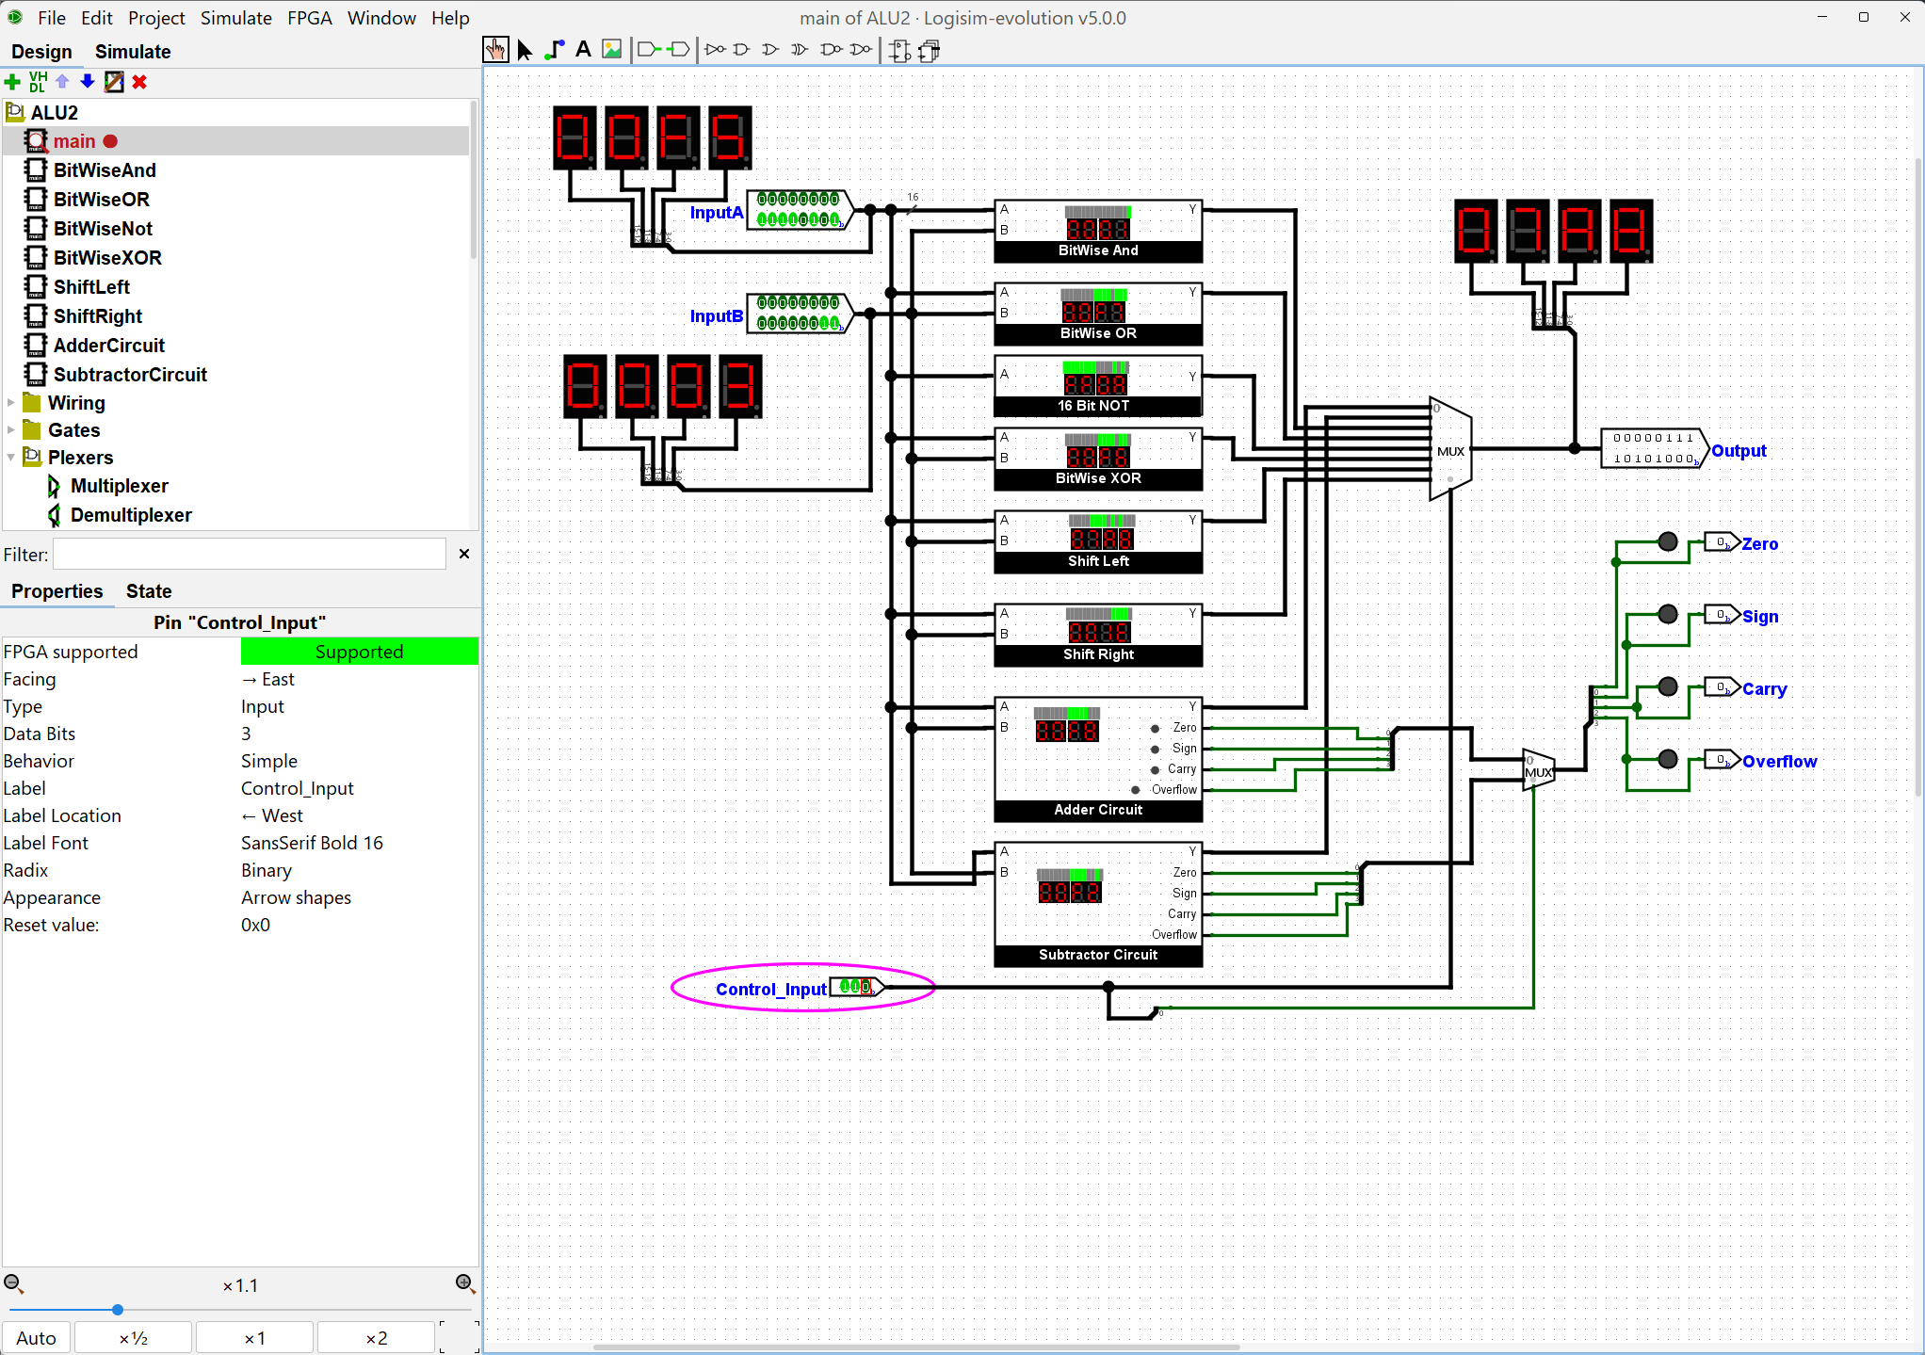  Inputs: A = 0000000011110101 (hex 00F5, decimal 245), B = 0000000000000011 (hex 0003, decimal 3), Control_Input = 110. Output: 0000011110101000 (hex 07A8, decimal 1960). A is shifted left by 3 places (the value in B's lowest 4 bits) and zeros fill in from the right. Shifting left by 3 multiplies by 8: 245 x 8 = 1960.  Function 8: Shift A Right by B Bits (S2 S1 S0 = 111)  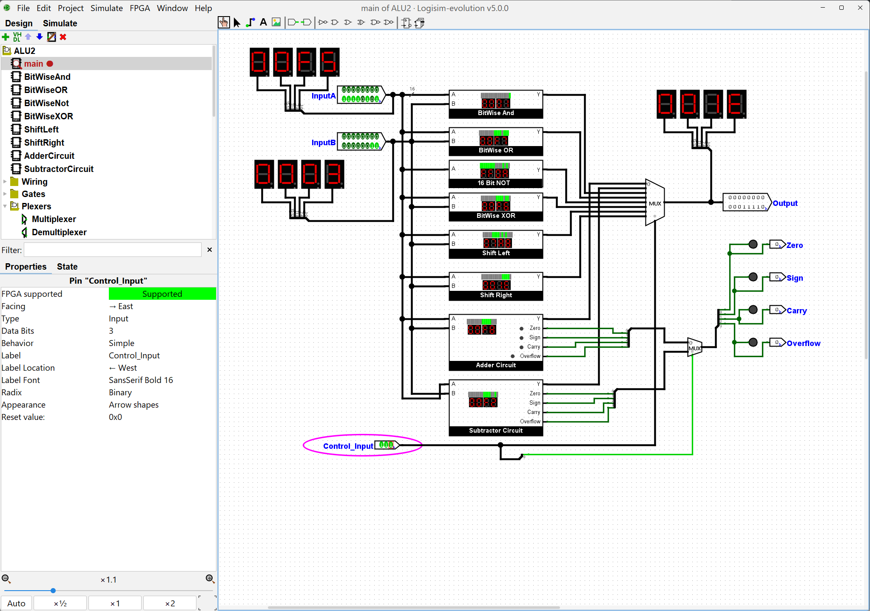  Inputs: A = 0000000011110101 (hex 00F5, decimal 245), B = 0000000000000011 (hex 0003, decimal 3), Control_Input = 111. Output: 0000000000011110 (hex 001E, decimal 30). A is shifted right by 3 places and zeros fill in from the left. Shifting right by 3 divides by 8 and drops the remainder: 245 / 8 = 30.  PART B: INDIVIDUAL SUBCIRCUIT TESTS  Each subcircuit was also tested on its own before being used in main.  BitWiseAnd subcircuit  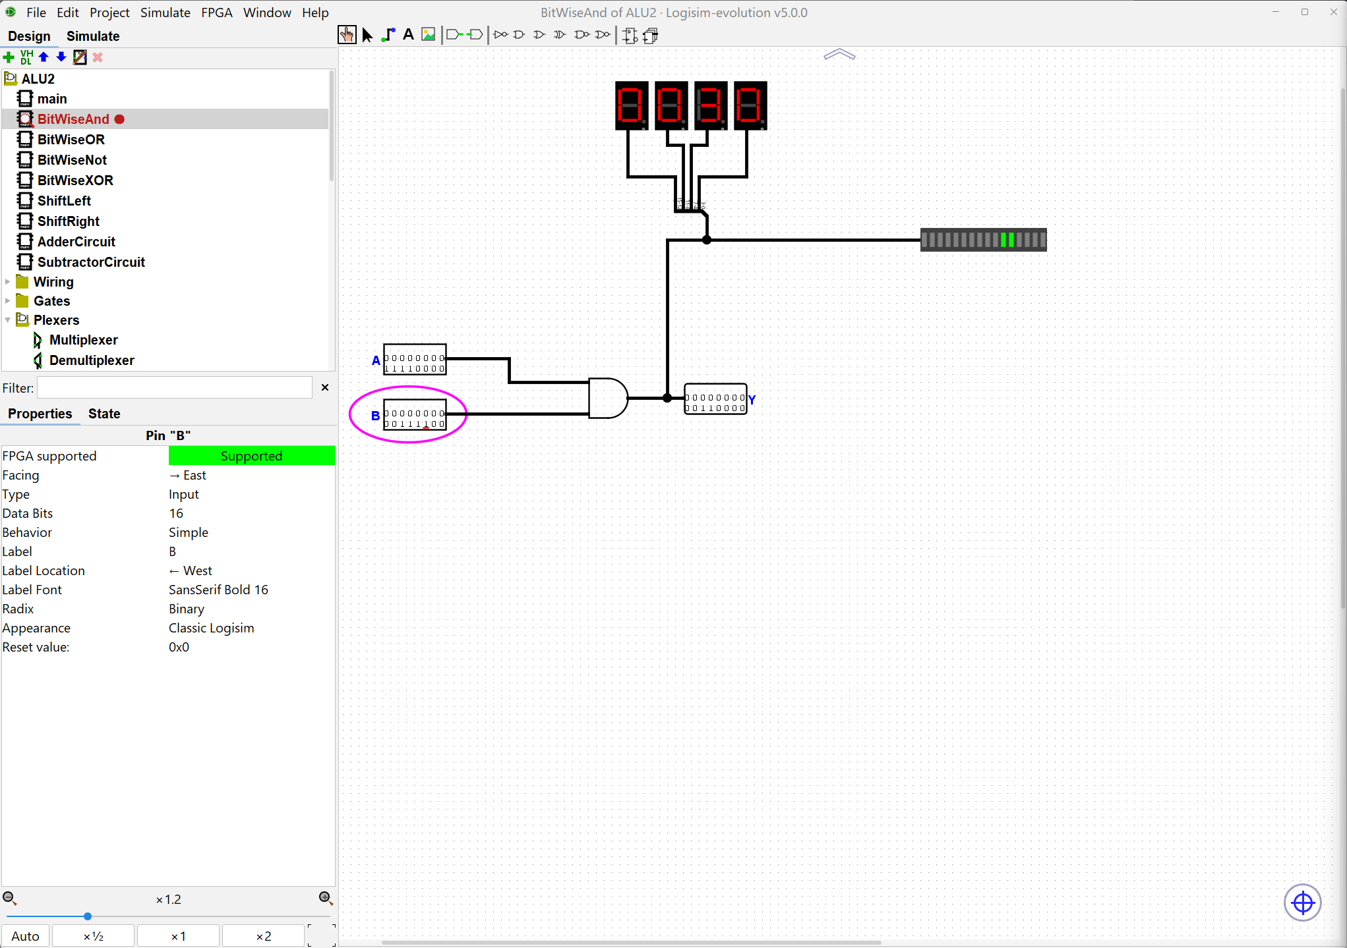  Inputs: A = 0000000011110000 (00F0), B = 0000000000111100 (003C). Output: Y = 0000000000110000 (0030). Only bits 4 and 5 are 1 in both inputs.  BitWiseOR subcircuit  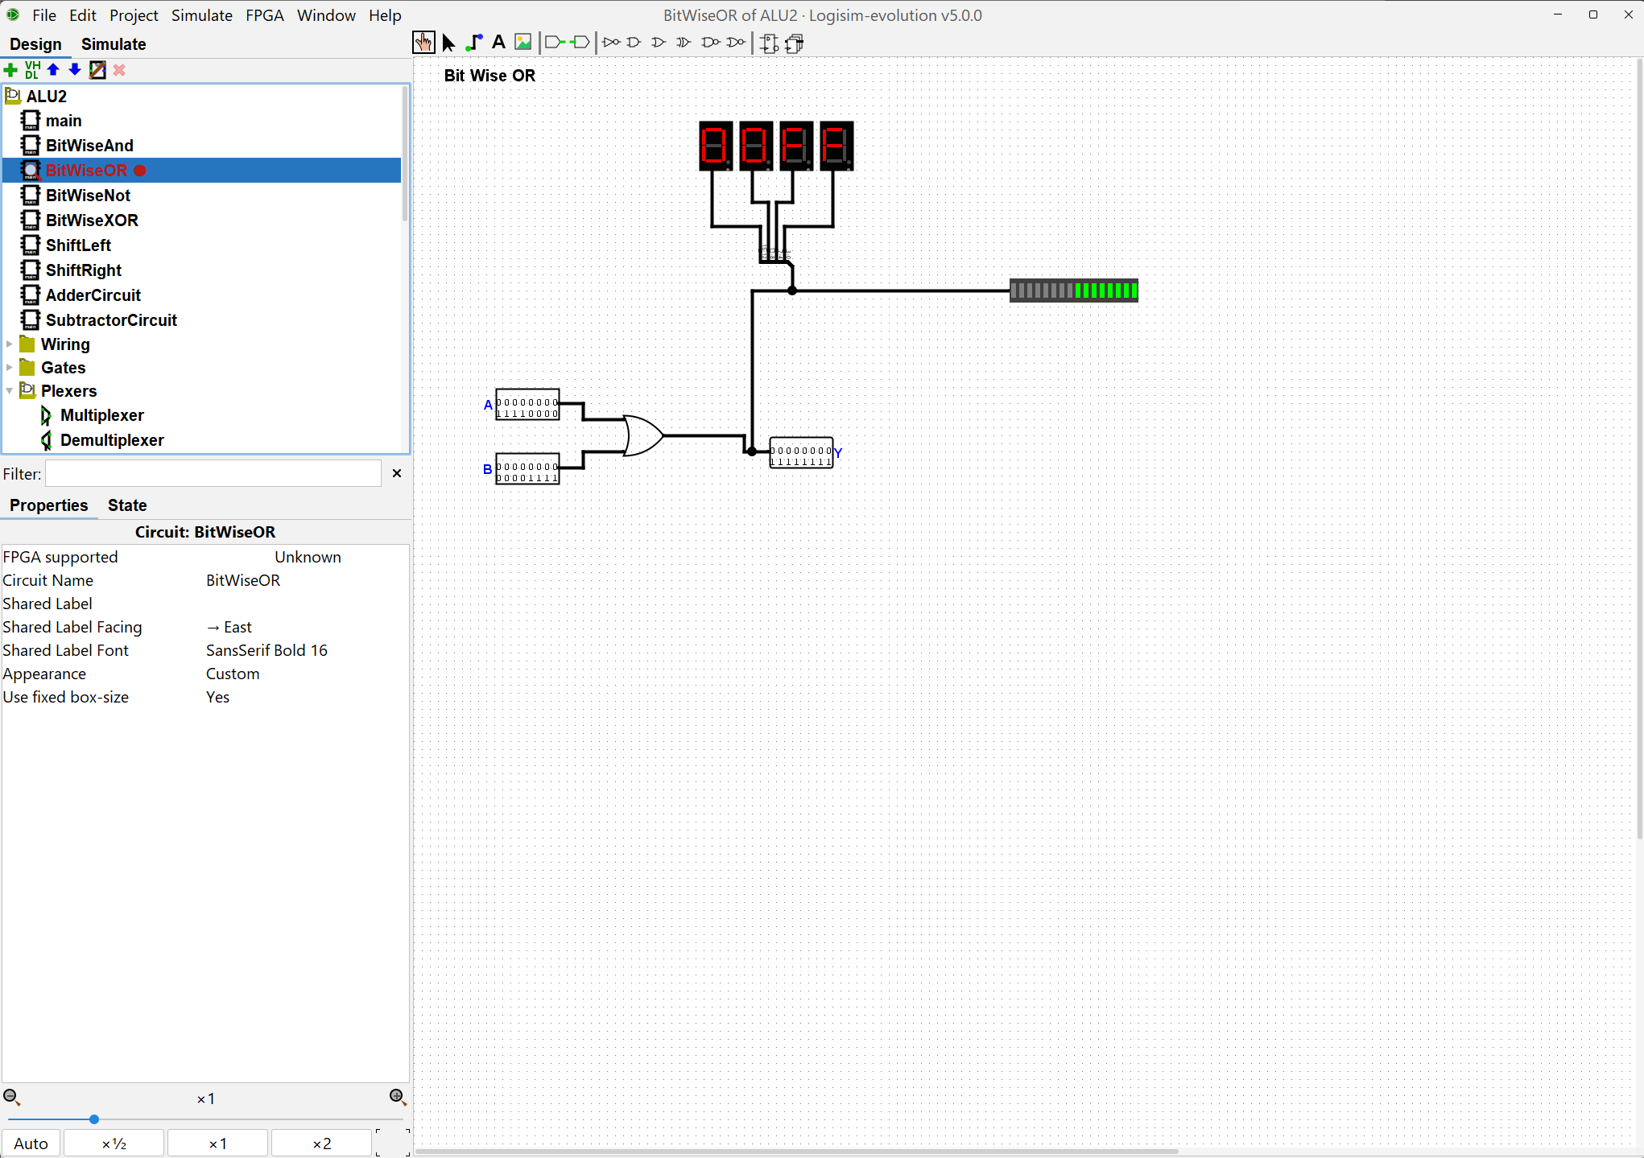  Built with a 16-bit OR gate. Inputs: A = 0000000011110000 (00F0), B = 0000000000001111 (000F). Output: Y = 0000000011111111 (00FF). Every bit that is 1 in either input is 1 in the output.  BitWiseNot subcircuit  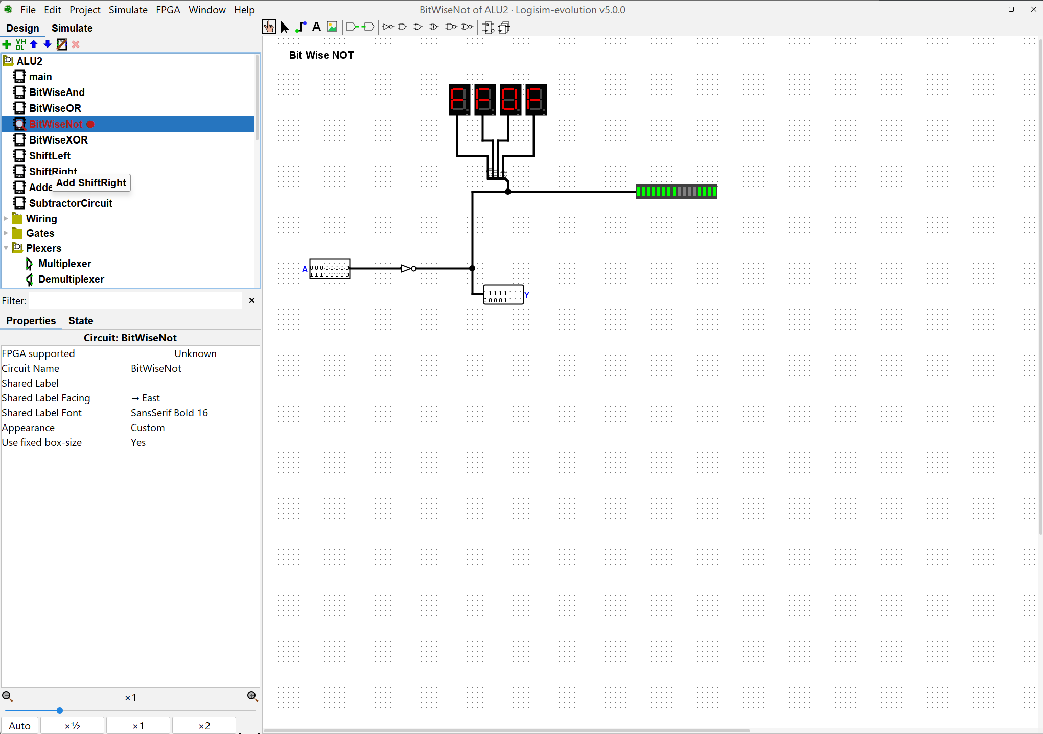  Built with a 16-bit NOT gate. Input: A = 0000000011110000 (00F0). Output: Y = 1111111100001111 (FF0F). Every bit is inverted.  BitWiseXOR subcircuit  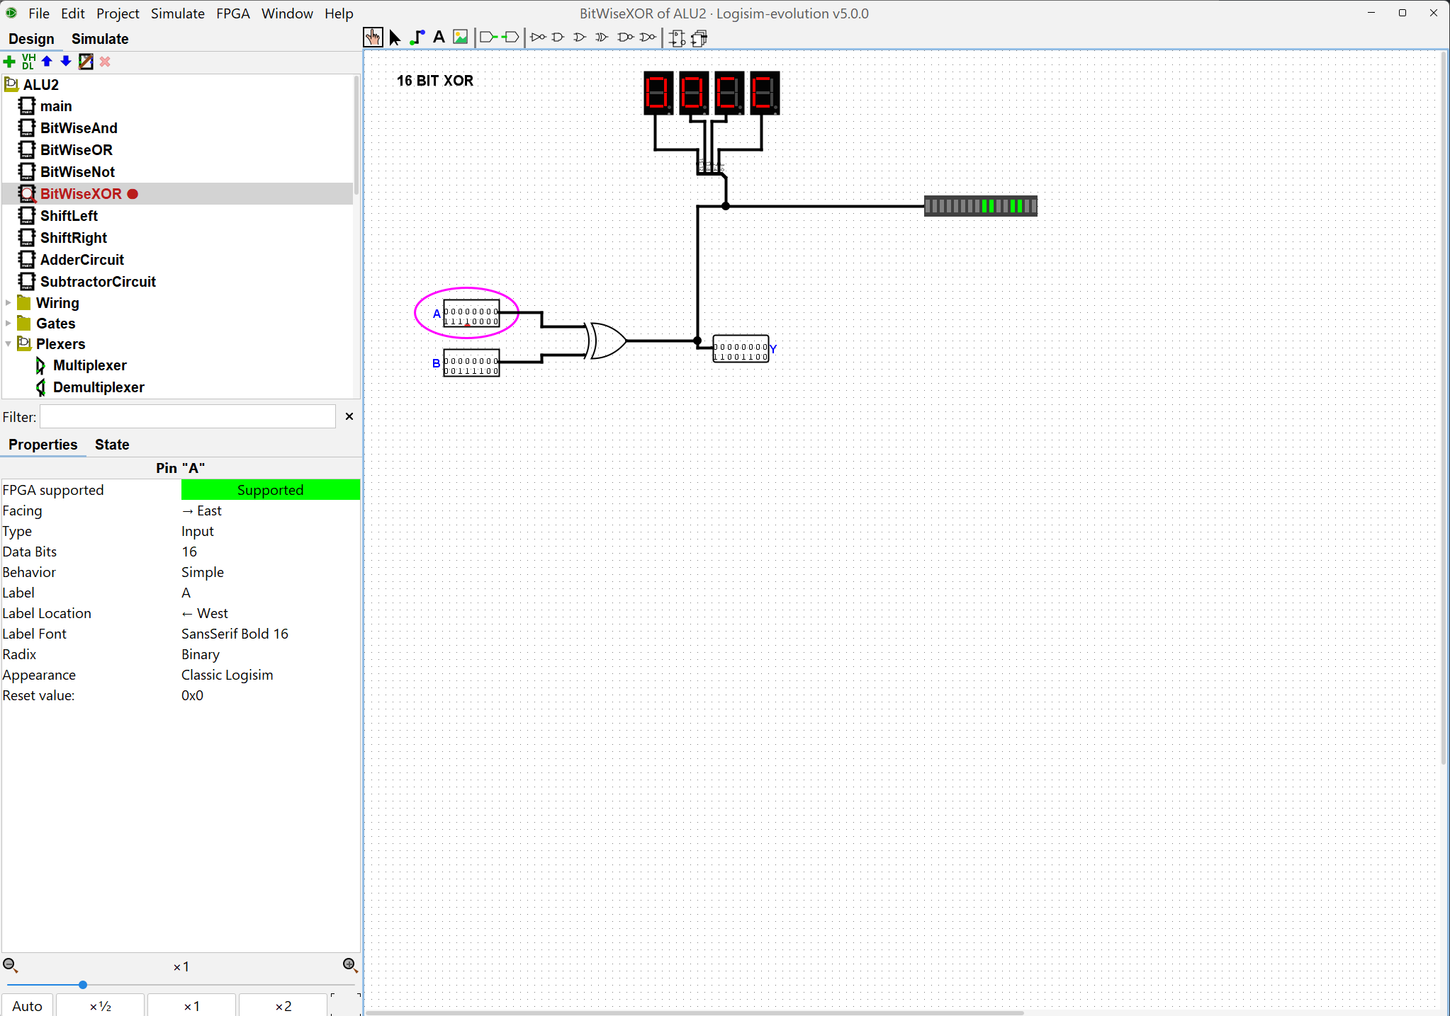  Built with a 16-bit XOR gate. Inputs: A = 0000000011110000 (00F0), B = 0000000000111100 (003C). Output: Y = 0000000011001100 (00CC). Bits are 1 only where A and B differ.  ShiftLeft subcircuit  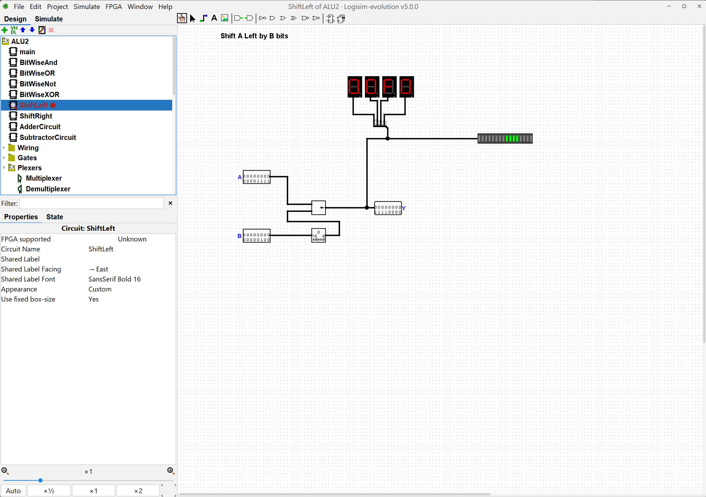  Built with a 16-bit Shifter set to Logical Left. A Bit Extender (16 bits in, 4 bits out) passes only B's lowest 4 bits to the shift-amount input. Inputs: A = 0000000000001111 (000F), B = 0000000000000100 (shift by 4). Output: Y = 0000000011110000 (00F0).  ShiftRight subcircuit  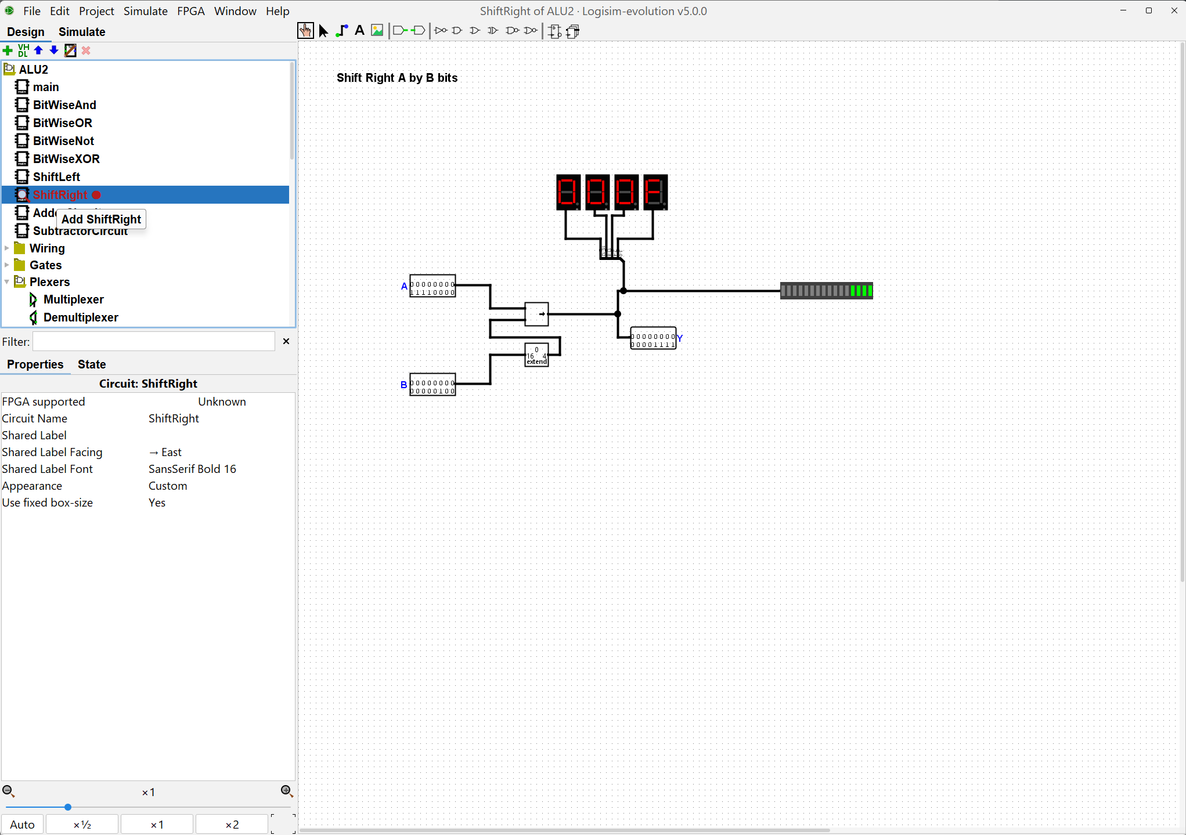  Built the same way as ShiftLeft, with the Shifter set to Logical Right. Inputs: A = 0000000011110000 (00F0), B = 0000000000000100 (shift by 4). Output: Y = 0000000000001111 (000F).  AdderCircuit subcircuit  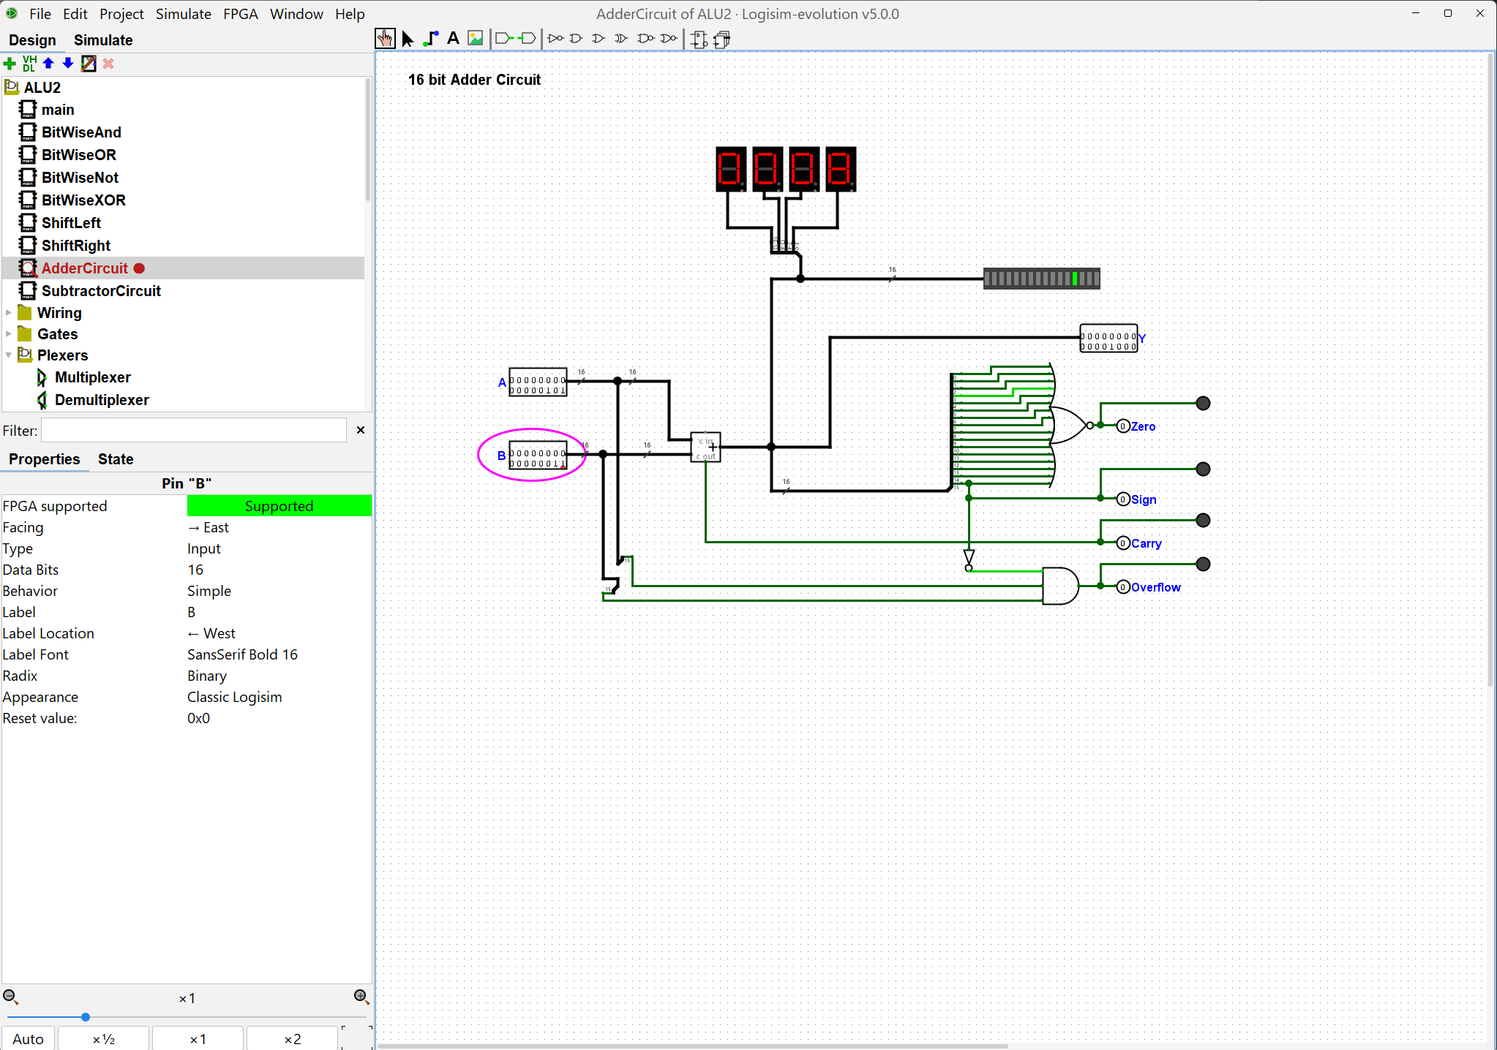  Inputs: A = 0000000000000101 (5), B = 0000000000000011 (3). Output: Y = 0000000000001000 (8). Zero, Sign, Carry and Overflow are all 0. Zero comes from a 16-input NOR of the result bits, Sign is result bit 15, Carry is the adder's carry-out, and Overflow is A15 AND B15 AND NOT(S15).  SubtractorCircuit subcircuit  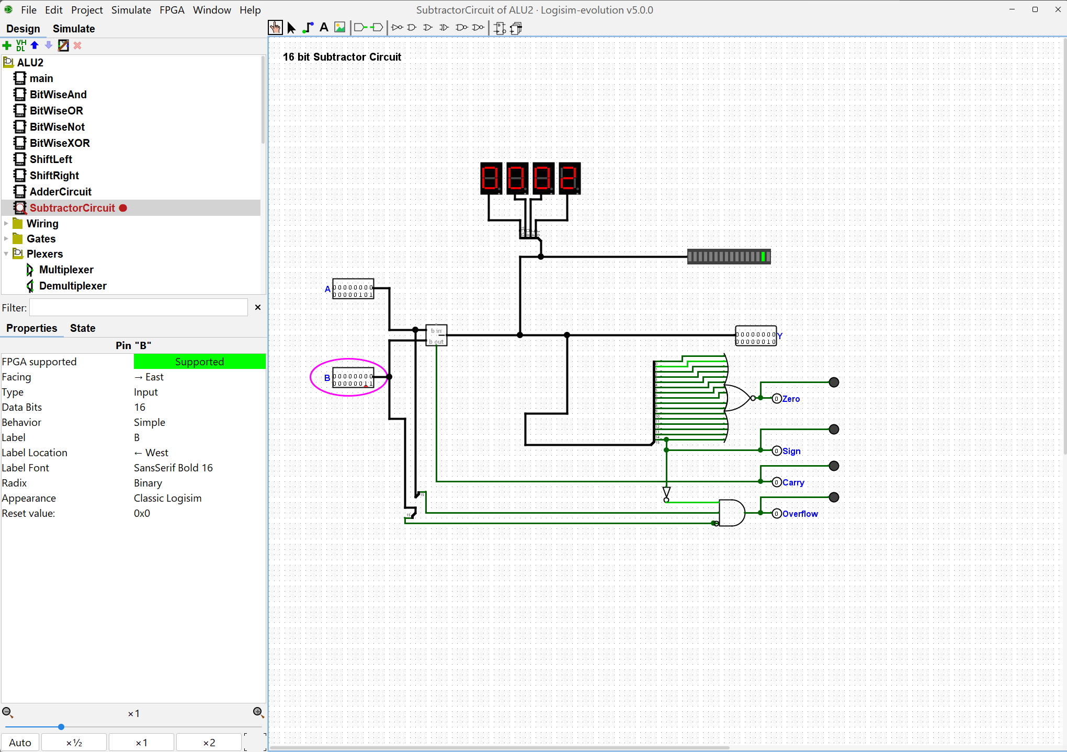  Built with a 16-bit Subtractor and the same flag structure as the Adder: Zero from a 16-input NOR, Sign from result bit 15, and Carry from the borrow-out. Overflow is A15 AND NOT(B15) AND NOT(S15). Inputs: A = 0000000000000101 (5), B = 0000000000000011 (3). Output: Y = 0000000000000010 (2), with all flags 0. In a separate check, A = 8000 and B = 0001 gave Y = 7FFF with Overflow = 1, as expected.

